**FAST NUCES LAHORE**

**ITC LAB PROJECT**

**HAFIZ AHMAD**

**19L-1316**

**EE-2A**

**TO: AROOSA UMAIR**

**DEADLINE: 23 MAY 2020**

**PROJECT:**

**TIC TAK TOE GAME**

**PROJECT REPORT:**

**Introduction:**

**C++ is basic level of programming in which we learn the basics of programming and we also learn how to manage a project and how to make it best .It’s not difficult language but conceptual its take time to understand .In this project we learn again all the labs that we done in our class.**

**OBJECTIVE:**

* **IMPLEMENT A COMPUTER PROGRAM THAT PLAYS TIC TAK TOE GAME AGAINST ANOTHER PLAYER**
* **USE 2D- ARRAY**

**PROCEDURE:**

* **First of all we use predefined library for input and output of program are also called headerfiles.**
* **We call functions by reference we make 4 function in this project.**
* **Main(),display structure(),check(),player.**
* **First function is main function that call next function which is name as player function.**
* **In players function it first display the board and games start and users enter the position by one and two player.**
* **Display board function in which it displays the board designed and store numbers from 0 to 8 on show on console. And displays designed board on console.**
* **In check function we use if else statements to x=check the conditions of game wining if 3 boxes have same first ‘X’ or ‘O’ horizontally vertically and diagonally then its condtion true and call to player funtions user one or two wins the game congragulations to user display on console as you see in below screen shots.**
* **If users not wins the game no matches same horizontally vertically diagonally no space left then no one wins the game games tie condition show on console as you see below screen shot.**
* **Our main function in this project is players function which is void type first it displays the design board on console and it ask to enter the player one and player two one by one to enter the game we use loop that takes 9 time input from both users and check the condition if not win then the loop take input again and again if not win condition fails then hen its stops and show on console that user wins the game otherwise it takes input again and again.**
* **In while loop we how we take input again and again its procedure is that we take int type variable and sets to 0 first time loop start user take input by first player and after entering the position its show on console then we upgrade our turn into plus one then take input when turn is 1 is goes to if condition which is false and its goes to else statement which is second player by this we take input from both users again and again.**
* **The important is that we replace out player enter position by x and o it can be done by ‘i’ row and ‘j’ column by we divide ‘i’ by 3 and then take mode of ‘j’ by 3 and call to board position which we enter and store our variable.by use of this we we store our character.**
* **Thanks for reading my procedure.**

**PROJECT CODE:**

#include <iostream>

using namespace std;

char board[3][3]={{'0','1','2'},{'3','4','5'},{'6','7','8'}};

void displaystructure(int, int, char);

bool check();

void players()

{

cout<<" *******************************"<<endl;

cout<<" TIC TAC TOE PLAY BORAD "<<endl;

cout<<" *******************************"<<endl;

cout<<" PLAYER NO 1 = X : PLAYER NO 2 = O"<<endl;

cout<<" "<<endl;

cout<<" "<<endl;

cout<<" "<<endl;

cout<<" "<<endl;

cout<<" "<<endl;

cout<<" _____________________________________"<<endl;

cout<<" || || || ||"<<endl;

cout<<" "<<board[0][0]<<" "<<board[0][1]<<" "<<board[0][2]<<endl;

cout<<" || || || ||"<<endl;

cout<<" _____________________________________"<<endl;

cout<<" || || || ||"<<endl;

cout<<" "<<board[1][0]<<" "<<board[1][1]<<" "<<board[1][2]<<endl;;

cout<<" || || || ||"<<endl;

cout<<" _____________________________________"<<endl;

cout<<" || || || ||"<<endl;

cout<<" "<<board[2][0]<<" "<<board[2][1]<<" "<<board[2][2]<<endl;

cout<<" || || || ||"<<endl;

cout<<" _____________________________________"<<endl;

int turn = 0; // 0 means turn of player 1, 1 means turn of player 2;

int position;

int i, j;

char enter;

bool win = false;

int boardcomplete = 0;

while (!win && boardcomplete != 9)

{

if(turn == 0)

{

cout<<"ENTER THE POSITION PLAYER NO 1:";

cin>>position;

enter = 'X';

}

else

{

cout<<"ENTER THE POSITION PLAYER NO 2:";

cin>>position;

enter = 'O';

}

i = position/3;

j = position%3;

displaystructure(i,j,enter);

boardcomplete++;

win = check();

if(win)

{

if(turn == 0)

{

cout<<" "<<endl;

cout<<" "<<endl;

cout<<" "<<endl;

cout<<" "<<endl;

cout<<" "<<endl;

cout<<" * * * * * * * "<<endl;

cout<<" * * * * * * * "<<endl;

cout<<" * * * * * * *"<<endl;

cout<<" * PLAYER NO 1 WINS THE GAME *"<<endl;

cout<<" * * * * * * * "<<endl;

cout<<" * * * * * * *"<<endl;

cout<<" * * CONGRAGULATIONS * * "<<endl;

cout<<" * * * * * * * "<<endl;

cout<<" * * * * * * * "<<endl;

cout<<" * * * * * * * "<<endl;

cout<<" "<<endl;

cout<<" "<<endl;

cout<<" "<<endl;

cout<<" "<<endl;

cout<<" "<<endl;

system("pause");

}

else

{

cout<<" "<<endl;

cout<<" "<<endl;

cout<<" "<<endl;

cout<<" "<<endl;

cout<<" "<<endl;

cout<<" * * * * * * * "<<endl;

cout<<" * * * * * * * "<<endl;

cout<<" * * * * * * *"<<endl;

cout<<" * PLAYER NO 2 WINS THE GAME *"<<endl;

cout<<" * * * * * * * "<<endl;

cout<<" * * * * * * *"<<endl;

cout<<" * * CONGRAGULATIONS * * "<<endl;

cout<<" * * * * * * * "<<endl;

cout<<" * * * * * * * "<<endl;

cout<<" * * * * * * * "<<endl;

cout<<" "<<endl;

cout<<" "<<endl;

cout<<" "<<endl;

cout<<" "<<endl;

cout<<" "<<endl;

system("pause");

}

}

turn = (turn+1)%2;

}

if(!win)

{

cout<<" "<<endl;

cout<<" "<<endl;

cout<<" "<<endl;

cout<<" "<<endl;

cout<<" "<<endl;

cout<<" YOUR GAME IS TIE NO MORE PLACE"<<endl;

cout<<" "<<endl;

cout<<" "<<endl;

cout<<" "<<endl;

cout<<" "<<endl;

cout<<" "<<endl;

system("pause");

}

}

void displaystructure(int i, int j, char temp)

{

board[i][j] = temp;

cout<<" *******************************"<<endl;

cout<<" TIC TAC TOE PLAY BORAD "<<endl;

cout<<" *******************************"<<endl;

cout<<" PLAYER NO 1 = X : PLAYER NO 2 = O"<<endl;

cout<<" "<<endl;

cout<<" "<<endl;

cout<<" "<<endl;

cout<<" "<<endl;

cout<<" "<<endl;

cout<<" _____________________________________"<<endl;

cout<<" || || || ||"<<endl;

cout<<" "<<board[0][0]<<" "<<board[0][1]<<" "<<board[0][2]<<endl;

cout<<" || || || ||"<<endl;

cout<<" _____________________________________"<<endl;

cout<<" || || || ||"<<endl;

cout<<" "<<board[1][0]<<" "<<board[1][1]<<" "<<board[1][2]<<endl;;

cout<<" || || || ||"<<endl;

cout<<" _____________________________________"<<endl;

cout<<" || || || ||"<<endl;

cout<<" "<<board[2][0]<<" "<<board[2][1]<<" "<<board[2][2]<<endl;

cout<<" || || || ||"<<endl;

cout<<" _____________________________________"<<endl;

}

bool check()

{

if(board[0][0]==board[0][1] && board[0][1]==board[0][2])

{

return true;

}

else if(board[1][0]==board[1][1] && board[1][1]==board[1][2])

{

return true;

}

else if(board[2][0]==board[2][1] && board[2][1]==board[2][2])

{

return true;

}

else if(board[0][0]==board[1][0] && board[1][0]==board[2][0])

{

return true;

}

else if(board[0][1]==board[1][1] && board[1][1]==board[2][1])

{

return true;

}

else if(board[0][2]==board[1][2] && board[1][2]==board[2][2])

{

return true;

}

else if(board[0][0]==board[1][1] && board[1][1]==board[2][2])

{

return true;

}

else if(board[0][2]==board[1][1] && board[1][1]==board[2][0])

{

return true;

}

else

{

return false;

}

}

int main()

{

players();

return 0;

}

**CODE OUTPUT:**

**DISPLAY:**

OUTPUT DISPLAY ON CONSOLE:

USERS TO ENTER THE POSITION TO ENETR THE GAME:

IT ALSO TELLS THAT PLAYER 1 = X AND PLAYER NO 2 = O NOW YOU ENETR THE PSOTION OF PLAYER ONE AND PALYER TWO AND LET START THE GAME:

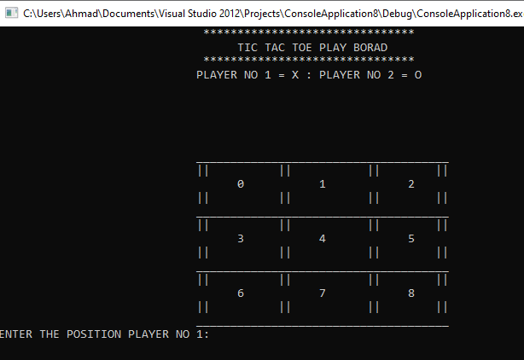

**GAME OVER CONDITION:**

IN THIS GAME IS OVER AND NO MORE SPACE LEFT TO ENTER SUCH AS WE SY THAT GAME IS TIE NO ONE WINS THE GAME:

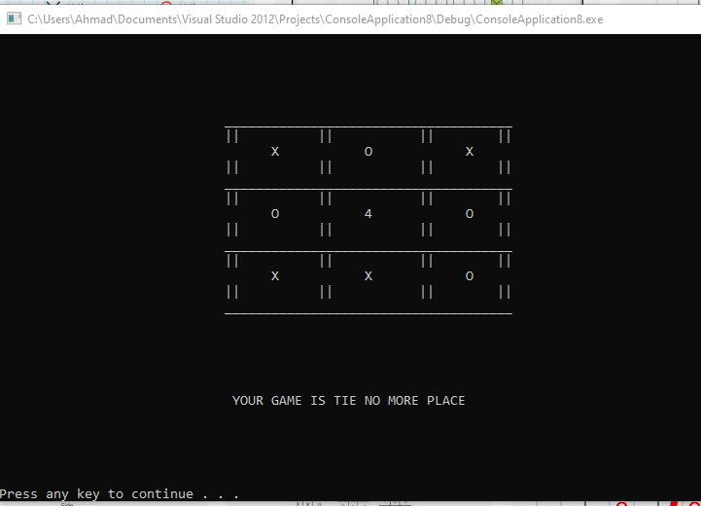

**GAME WINS:**

**PLAYER NO 1 WINS THE GAME :**

**THESE ARE THOSE 8 CONDITIONS IN WHICH PLAYER ONE WINS THE GAME**

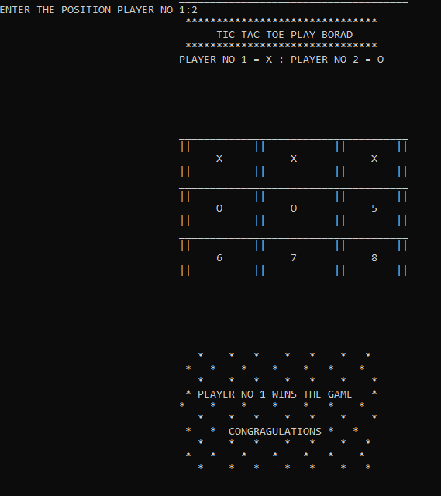

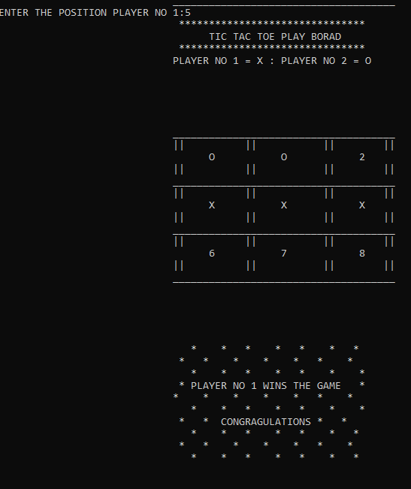

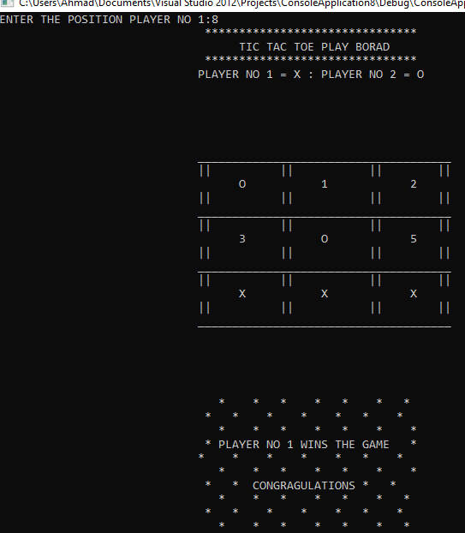

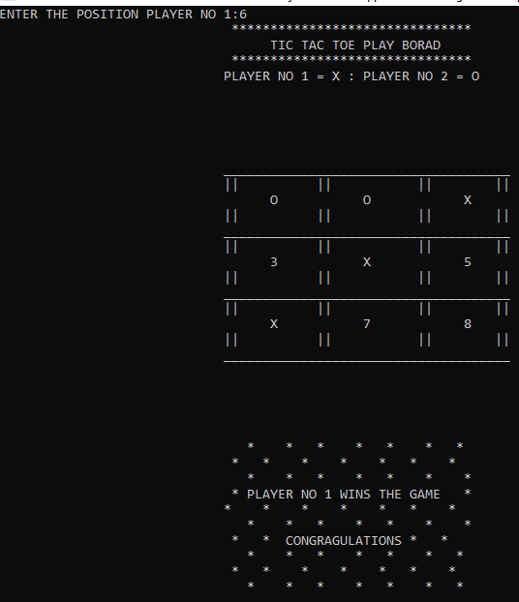

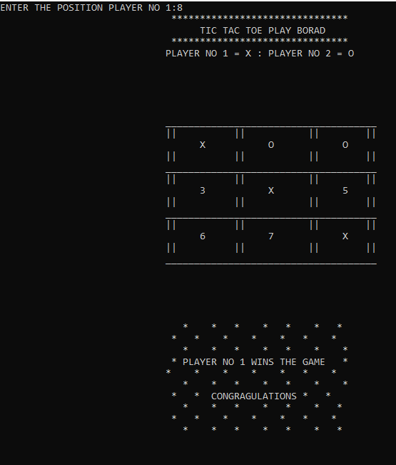

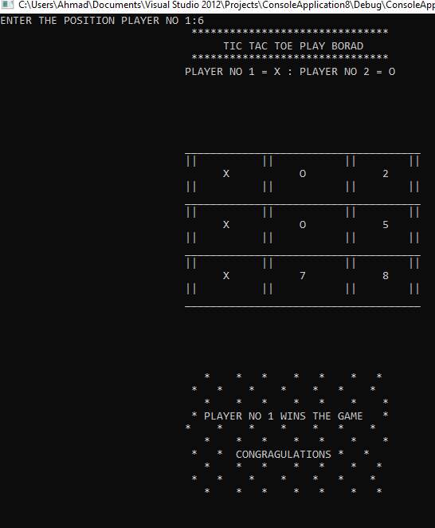

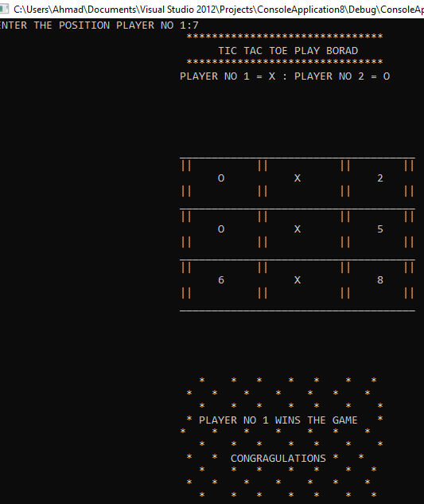 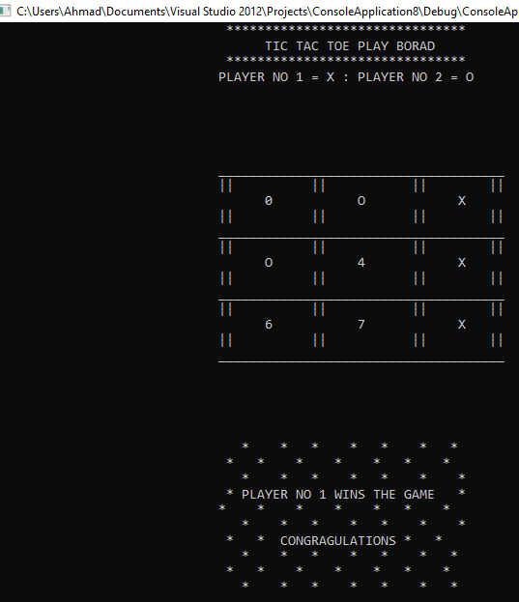

**PLAYER NO 2 WINS THE GAME:**

**THESE ARE THOSE 8 CONDITIONS IN WHICH PLAYER TWO WINS THE FAME**

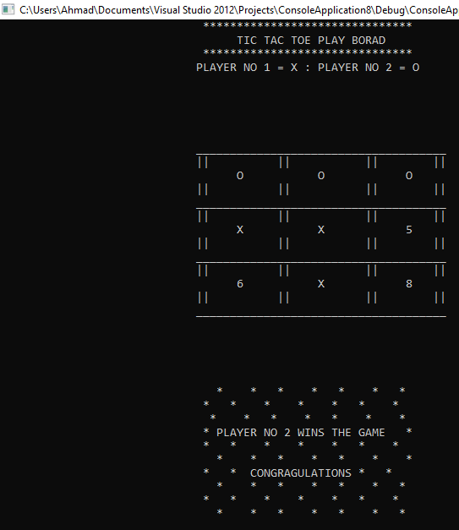 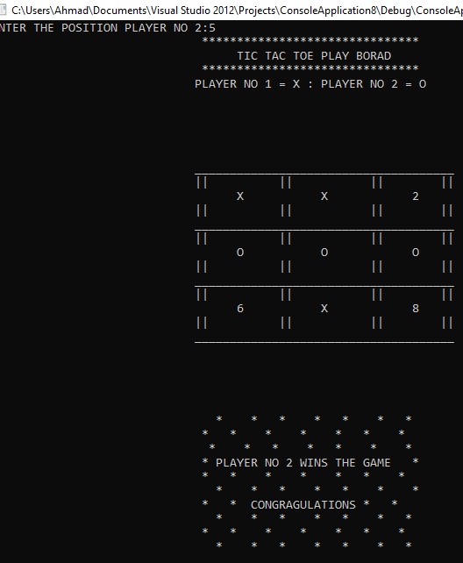 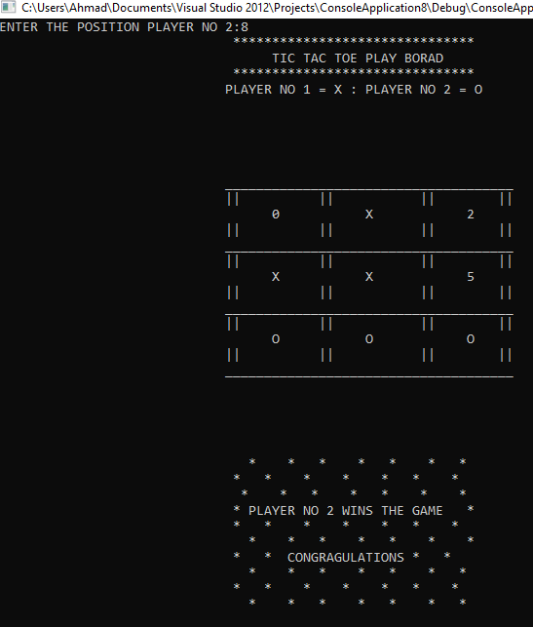

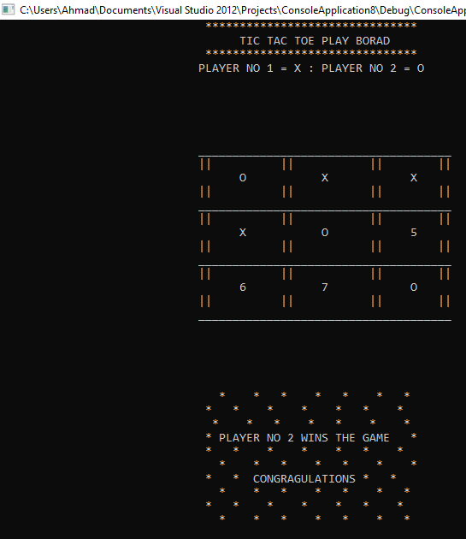

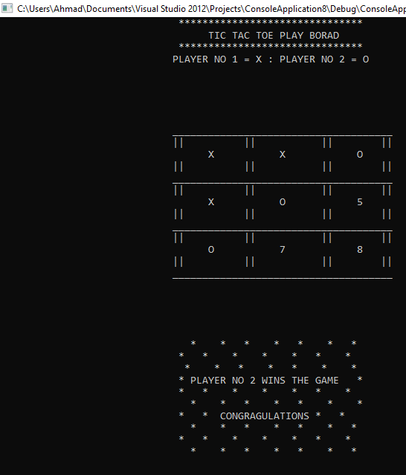

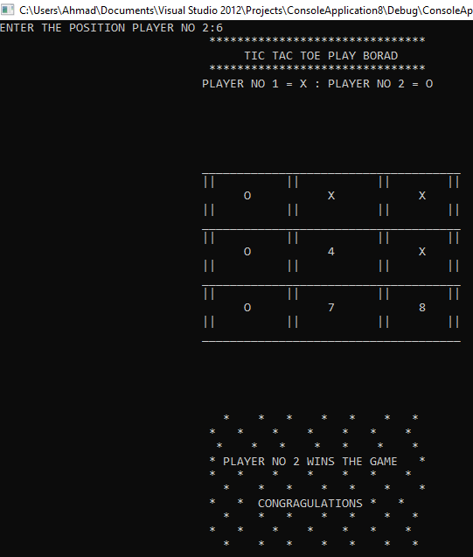

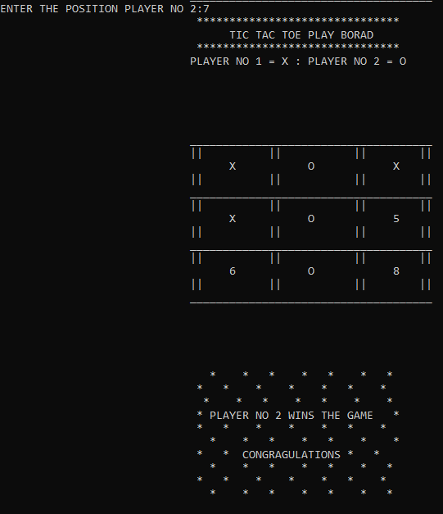

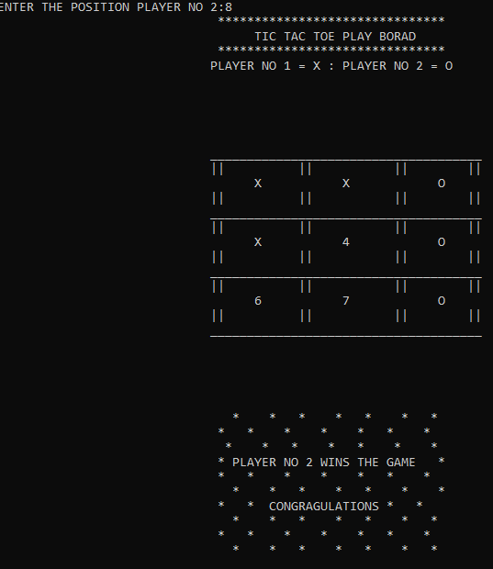

**CONCLUSION:**

**I THIS PROJECT WE LEARN HOW TO CODE A GAME ON COSOLE. ITS NOT DIFFICULT PROJECT.IN THIS WE LEARN MANAY THINGS NEW AFTER MAKING THE GAME. MY MAINLY WORK CONSIST FUNCTIONS CALLING.**

**THANK YOU**